|  |  |
| --- | --- |
| https://www.stjames.ie/intranet/oncampus/departments/communications/hospitallogos/St,James,Hospital,logo,Irish.jpg |  |

**Organization Profile,**

**Job and Person Specification**

**Associate Specialist in Nephrology**

**St. James’s Hospital- 35 hours**

**Reference ID: NEPH_2024**

**Permanent Appointment**

|  |  |  |  |  |  |  |
| --- | --- | --- | --- | --- | --- | --- |
|  |  |  |  |  |  |  |

**ORGANIZATION PROFILE:**

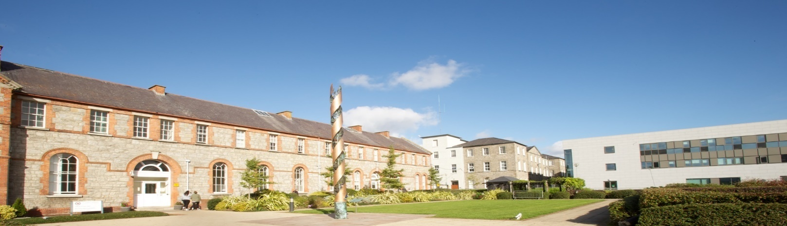

# About St James’s Hospital

St James’s Hospital is Ireland’s largest acute academic teaching hospital and is based in Dublin’s south inner city. The hospital is one of two Dublin-based state-owned large scale acute medical facilities constituted independently under Statute. The hospital has 1,066 inpatient beds and employs approximately 5,000 staff.

Our 60-acre campus houses the Trinity College Dublin Health Sciences Centre, Trinity College Dublin Translational Medicine Institute, Wellcome Trust/HRB Clinical Research Centre, Irish Blood Transfusion Service (IBTS), St Luke’s Radiation Oncology Centre, Centre for Advanced Medical Imaging, Emergency Medicine Department, National Medicines Information Centre, Johnathan Swift Clinic and St James’s Private Clinic.

The new National Children’s Hospital is co-located on the St James’s Hospital Campus with further development planned for the relocation of the Coombe Women and Infants University Hospital to the campus to facilitate an optimal tri-location of acute adult, paediatric and maternity services.

# Acute Service Provision

St James’s Hospital has the greatest number of clinical specialties, sub-specialities and national services in the acute adult hospital system in Ireland*. It has the largest medical oncology programme nationally and is a centre of excellence for the delivery of cancer care in Ireland, comparable in scale and complexity to other major European centres.

By international standards, St James’s Hospital is a significant acute hospital service provider. We provide acute, emergency, specialist services and residential care, across a vast range of medical and surgical specialties and place high emphasis on excellence of delivery, research, innovation and education.

# The development of an Academic Health Science Centre

With our academic partner Trinity College Dublin, our overarching ambition is to evolve into Ireland’s first Academic Health Science Centre (AHSC), in a fundamental reshaping of the hospital-university model.

The expertise of Trinity College Dublin as Ireland’s leading university, and St James’s Hospital as Ireland’s largest acute academic teaching hospital, means that the two institutions are uniquely placed to drive the establishment of Ireland’s first AHSC.

The strategic shift reflects international experience demonstrating that the integration of education, research, innovation and clinical service delivery in an Academic Health Science Centre model significantly improves and enhances both patient care and research, contributes to innovation and the knowledge economy and improves staff retention and recruitment.

The AHSC will take a national lead in driving solutions to health infrastructure and better health performance. A healthier Ireland needs to be built inclusively, with key partners in localities, across government including the Department of Health, the HSE, the private sector, and innovators.

|  |  |  |  |  |  |  |  |
| --- | --- | --- | --- | --- | --- | --- | --- |
|  | |  |  |  |  |  |  |
| **Trinity College, Dublin** | | | | | | | |
| With our academic partner Trinity College Dublin, our overarching ambition is to evolve into Ireland’s first Academic Health Science Centre (AHSC), in a fundamental reshaping of the hospital-university model.  The expertise of Trinity College Dublin as Ireland’s leading university, and St James’s Hospital as Ireland’s largest acute academic teaching hospital, means that the two institutions are uniquely placed to drive the establishment of Ireland’s first AHSC.  The strategic shift reflects international experience demonstrating that the integration of education, research, innovation and clinical service delivery in an Academic Health Science Centre model significantly improves and enhances both patient care and research, contributes to innovation and the knowledge economy and improves staff retention and recruitment.  The AHSC will take a national lead in driving solutions to health infrastructure and better health performance. A healthier Ireland needs to be built inclusively, with key partners in localities, across government including the Department of Health, the HSE, the private sector, and innovators.  The defining feature of an AHSC is the commitment of pursuing a tripartite mission of:     1. Achieving high standards of clinical care 2. Leading clinical and laboratory research and 3. Educating doctors and other health professionals.   A key objective is to improve clinical quality and health outcomes, informed by excellent research and education to leverage the value of integrating the tri-partite mission of service, education, research and innovation for the benefit of patients, the community and the knowledge economy. | | | | | | | |

|  |
| --- |
| **Mercer’s Institute for Successful Ageing** |
| The Mercer’s Institute for Successful Ageing (MISA) at St James’s Hospital is an exemplar of how we see an AHSC developing on site - on an institute by institute basis. MISA is a state-of-the-art-facility for integrated clinical services and a hub for world-leading research in ageing. The Institute promotes coordinated patient-centred care, coupled with far-reaching educational and training programmes. Responding to the need for innovation in the delivery of services for Ireland’s ageing population, the institute:   * provides early diagnostic and rapid access care clinics, along with inpatient acute assessment, rehabilitation, and continuing care units * delivers innovative research and develops technologies with industry partners to advance healthy life-years * serve as a local resource to the surrounding community, while offering Ireland a national centre for successful ageing.     The Mercer’s Institute for Successful Ageing was built successfully using a combination of philanthropic and state funding on time and within budget, following a very generous grant from Chuck Feeney’s Atlantic Philanthropies. |

|  |  |  |  |  |  |  |
| --- | --- | --- | --- | --- | --- | --- |
|  |  |  |  |  |  |  |

|  |
| --- |
| **The Wellcome HRB Clinical Research Facility (CRF)** |
| The Wellcome HRB Clinical Research Facility (CRF) is fully embedded in St James’s Hospital and is central to the clinical research activity taking place on campus. It contributes to an environment of top quality patient care as research active hospitals are associated with better patient outcomes.  Opened by An Taoiseach in May 2013, the CRF is a partnership between Trinity College Dublin and St James’s Hospital. It was built and equipped with approximately €12.5M in funding from the Wellcome Trust, a UK based research charity.  The facility supports and conducts a wide range of studies from observational studies to complex clinical trials. It provides Irish patients with early access to novel and life changing therapeutics for costly to treat conditions like Haemophilia A and Spinal Muscular Atrophy. It also supports early stage evaluation of point of care manufacture of CAR-T and other cell therapies for the treatment of cancer. The facility supports Medtech and Biotech start-up and campus spin-out companies including: Neuromod, Selio Medical, ProVerum and aCGT Vector  Currently the CRF employs approximately 20 staff. This highly specialised team work under a rigorous quality system that meets international standards (ICH-GCP) and has successfully completed Health Product Regulatory Authority Inspections.  **10,600 subjects have enrolled in studies and clinical trials with 23,800 subject visits have been facilitated in the CRF since 2013.** |

|  |
| --- |
| **Lean Transformation in Healthcare** |
| St James’s Hospital recognises the need to develop a health system that is sustainable and capable of delivering consistently high-quality services.  In 2021, to achieve our strategic ambition, St James’s Hospital partnered with the Virginia Mason Institute (VMI) to understand the Virginia Mason Production System (VMPS), a lean management methodology based on the principles of the Toyota Production System (TPS). The Virginia Mason Institute was founded in 2008 and is a non-profit organisation specialising in healthcare transformation. As a proof of concept, through education, coaching and facilitation, VMI worked with St James's Hospital to help us build the organisational capability needed to create and sustain a culture of continuous improvement.  The aim of the Lean Transformation programme is to ensure that every patient gets the right care, in the right place at the right time by:   * optimising resource utilisation and removing waste from the system; to include productivity, efficiency, effectiveness, workforce, equipment and space; * ensuring exemplar digitisation of operations and processes; * promoting a culture of continuous improvement; and * empowering frontline staff to drive improvement efforts.  The hospital’s Lean Transformation Office has identified many speciality areas of focus including improving, redesigning and transforming processes in scheduled and unscheduled care; conducting rapid movement events in areas such as day theatre optimisation and day of surgery admissions; and large scale improvement events to support ambulatory care pathways. |

|  |  |  |  |  |  |  |
| --- | --- | --- | --- | --- | --- | --- |
|  |  |  |  |  |  |  |

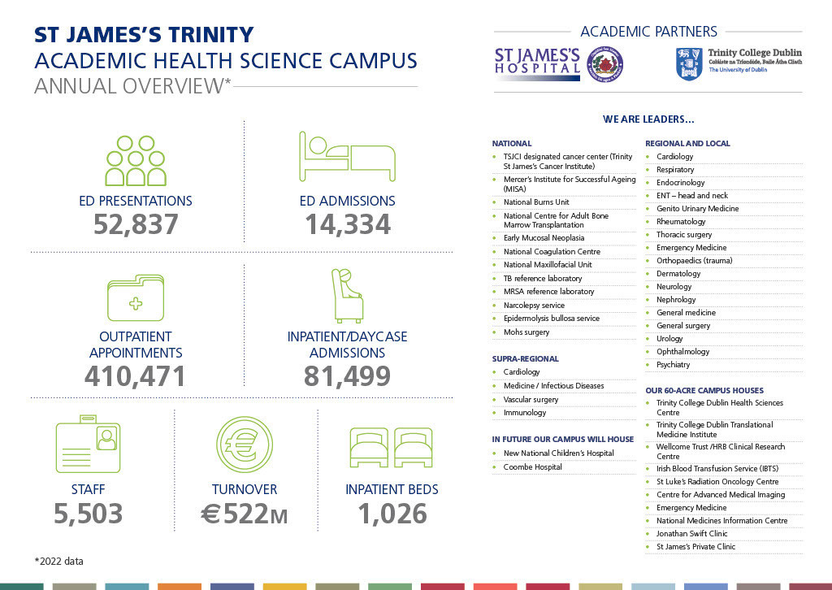

**Directorate and Departmental Profile**

|  |
| --- |
| The Medicine and Emergency Directorate (MED), which includes all specialties in Internal Medicine, was established in 2014 and had the effect of consolidating all specialties of medicine within a single clinical governance structure. It’s mission, aims and objectives focus on safety, (zero harm), quality, (excellent outcomes), patient experience, access and flow.  The Directorate has agreed a clinically-led management cycle for continuous improvement across its specialties. Clinical Specialty Leads have been appointed and a common structure and data-driven approach to specialty and directorate operations meetings has been agreed.  At directorate level, patient flow in MED is divided into 4 “pillars” – the acute floor, inpatient care, day procedures and ambulatory care. From a governance perspective, the various MED specialties are also mapped onto these pillars, each of which is managed by an Assistant Director of Nursing and Directorate Services Manager. |

|  |
| --- |
| **Nephrology Department**  St. James’s Hospital provides renal services to the Hospital’s local catchment area of 0.6 million people and additionally to many patients attending St James hospital for specialised regional and national services. These specialised services include malignant haematology and oncology, benign haematology including the national coagulation centre and adult sickle cell service. St James also provides plastics and burns services, cardiothoracic surgery and is preparing to realise the clinical synergies that informed co-location with the National Children’s Hospital. Acute haemodialysis occurs on site for inpatients and for outpatients from the SJH chronic kidney disease programme commencing haemodialysis. Patients transfer to a HSE contracted satellite unit, Tallaght Beacon Cross or to Tallaght University Hospital (where care continues to be provided by the SJH consultant through TUH contractual or seconded hours for this purpose) for chronic haemodialysis. Home therapies are currently accessed via Tallaght University Hospital although there is recognition of the need for a Home Therapies Clinical Nurse Specialist at St James Hospital to ensure outpatients are informed about home therapies throughout their journey and to support and educate the SJH Nursing body to provide peritoneal dialysis to inpatients attending for specialist services. There is a growing number of recent transplants following at St James Hospital.  It is envisaged that the successful applicant will oversee the outreach care of SJH originating haemodialysis patients, with particular emphasis on transplant work-up and admission avoidance and additionally contribute to outpatient clinic services and to the renal rota. With growing numbers of newly transplanted patients returning to St James Hospital, transplant experience is welcome. The St James renal department has a number of digital and clinical initiatives in place with the purpose of making the department more community facing and inclusive and accessible and experience in service development and innovation is desirable. |

**JOB SPECIFICIFATIONS**

|  |  |
| --- | --- |
| https://www.stjames.ie/intranet/oncampus/departments/communications/hospitallogos/SJH,Crest.jpg | KEY DUTIES AND RESPONSIBILITIES |
| **Clinical**   * Fulfil duties under nominated Consultant Nephrologist under the Board of St James’s Hospital. * Participate in the provision and administration of renal services for patients at St. James’s Hospital * Provide renal consultation services as required to patients in St. James's Hospital under Consultant guidance * Attendance at Multi-Disciplinary Teams meetings, as required * Supervise and take responsibility for clinical work and record keeping of all non-consultant hospital doctors and auxiliary staff attached to the department. * Together with colleague(s) in Nephrology, have a supportive role in shaping the policy with regard to the management of renal and general medicine services, best practice and accreditation. * Attend and participate in meetings relevant to the post, e.g. appropriate divisions and Directorate meetings. * Liaise with the Chief Executive Officer, Management Team, Clinical Director, relevant senior Medical and Nursing staff in all matters pertaining to the general efficiency of the Hospital. * Perform such other duties appropriate to his/her office as may be assigned to him/her by the Chief Executive Officers of St. James’s Hospital  Education  * Contribute to training and supervision of in the Department * Supervision of audits and research carried out by NCHD’s * Participation in the education and training of staff in Nephrology * Participation in education sessions for NCHDs, nurses, allied health professionals and undergraduate students * Participation in ongoing CPD programs  Research and audit  * Performance of appropriate research in **Nephrology**, and in collaboration with other researchers within the hospital * Participation and promotion of clinical audit within the department, the wider hospital and on a national and international level   **On-Call commitments**   * The successful candidate will be rostered according to departmental schedules and on call rosters and in accordance with contractual obligations. Associate Specialists are required to submit a detailed practice plan outlining weekly commitment to the department. This will be used to create a template for the weekly schedule and will allow for monitoring of duties.   **The above Job Description is not intended to be a comprehensive list of all duties involved and consequently, the post holder may be required to perform other duties as appropriate to the post which may be assigned to him/her from time to time and to contribute to the development of the post while in office. This document must be regarded as an outline of the major areas of accountability at the present time, which will be reviewed and assessed on an on-going basis.** | |

|  |  |
| --- | --- |
| https://www.stjames.ie/intranet/oncampus/departments/communications/hospitallogos/SJH,Crest.jpg | SKILLS AND KNOWLEDGE |
| **Clinical Care:** To demonstrate the ability to provide a level of clinical care required by this post according to the standards and requirements set by statutory and regulatory bodies, e.g. CAI, JFICM etc.  **Communication**: To illustrate a high level of verbal and non-verbal skills in order to effectively communicate with and relate to patients and / or parents / family, colleagues, hospital staff and management.  **Administration & Management Skills**: To demonstrate a satisfactory level of proficiency so as to enable the appointee to manage his/her staff and service and to be able to interact with and participate in hospital management structures as required. Furthermore, the appointee should demonstrate the ability to lead, supervise and be responsible for the clinical work of his / her multi-professional team.  **Organisational Awareness:** Provide evidence of knowledge and understanding of the structure and governance of this and similar organisations.  **Teaching**: To demonstrate skills required for educational training to medical students, professions.  **Research:** To demonstrate a proven ability and track record of engagement in research relating to the speciality.  **Continuing Education**: To demonstrate a proven record of undertaking C.M.E. and C.P.D.  **Audit**: The appointee would be expected to have an interest in, and prior experience of health services related research, data management and audit would be valuable in order to support the ongoing research and academic activity of the St James's Hospital Nephrology Department. | |
|  | |
| https://www.stjames.ie/intranet/oncampus/departments/communications/hospitallogos/SJH,Crest.jpg | REPORTING TO: |
| Reports and is accountable to the relevant head of department. | |
|  | |
| https://www.stjames.ie/intranet/oncampus/departments/communications/hospitallogos/SJH,Crest.jpg | INFORMAL QUERIES TO : |
| Dr. Donal Sexton, Head of Department, Consultant Nephrologist and General Physician ,St. James’s Hospital; email: dsexton@stjames.ie and/or Dr. Brenda Griffin, Consultant Nephrologist, St James’s Hospital; email: bgriffin@stjames.ie | |

**Person Specification**

|  |  |
| --- | --- |
| https://www.stjames.ie/intranet/oncampus/departments/communications/hospitallogos/SJH,Crest.jpg | QUALIFICATIONS |
| **Essential:**  Registration in the General Specialist Division of the Register of Medical Practitioners maintained by the Medical Council in Ireland.  **Desirable:**   * MD/PHD   **Taking up Appointment**  The successful candidate will be required to take up duty no later than six months of being interviewed. | |

|  |  |  |
| --- | --- | --- |
| https://www.stjames.ie/intranet/oncampus/departments/communications/hospitallogos/SJH,Crest.jpg | PARTICULARS OF OFFICE | |
| Tenure | | Whole-time, Permanent, and Pensionable |
| Annual Salary: | | €130,093 per annum. |
| Probationary Period: | | Permanent appointment to this post is dependent upon the Employee satisfactorily completing a probationary period of 6 months. The probationary period may be extended at the discretion of the Employer for a further period of up to 6 months. |
| Pension Scheme: | | The candidate will be entered into one of the Hospital Superannuation Schemes dependant on your previous HSE service. |
| Working Hours: | | The employee is contracted to undertake such duties / provide such services as are set out in this Contract in the manner specified for 35 hours per week. |
| Annual, Conference, Course leave: | | All leave or planned absences, other than those described in the ‘Sick Leave policy’, must have prior approval from the head of Department.The annual leave entitlement is 30 working days per annum and as determined by the Organisation of Working Time Act 1997. |
| Sick leave: | | The employee may be paid under the Sick Pay Scheme for absences due to illness or injury. Granting of sick pay is subject to a requirement to comply with the Employer’s sick leave policy. |
| Clinical Indemnity Scheme | | This post is indemnified by the Clinical Indemnity Scheme. |
| Disciplinary & Grievance Procedures | | Please refer to the hospitals PPG’s page for full guidance. |

|  |  |
| --- | --- |
| https://www.stjames.ie/intranet/oncampus/departments/communications/hospitallogos/SJH,Crest.jpg | APPLICATION PROCESS |
| St. James’s Hospital is an equal opportunities employer and is committed to employment policies, procedures and practices which do not discriminate on grounds such as gender, civil status, family status, age, disability, race, religious belief, sexual orientation or membership of the travelling community. On that basis we encourage and welcome talented people from all backgrounds to join our staff community  Applications must be made via the electronic recruitment system. Details on how to register your profile can be found on the separate document entitled “Online Application Information Guide”.  Candidates will be required to attend in person before an interview board established by the St James’s Hospital Board. The Hospital Board will not be responsible for any expenses a candidate may incur in attendance for interview.  Declaration: Please review your cover letter and curriculum vitae carefully and check for any errors or omissions. False declaration or omission in support of your application will disqualify you from appointment. | |

|  |  |
| --- | --- |
| https://www.stjames.ie/intranet/oncampus/departments/communications/hospitallogos/SJH,Crest.jpg | CLOSING DATE |
| 01/12/2024 | |

|  |  |
| --- | --- |
| https://www.stjames.ie/intranet/oncampus/departments/communications/hospitallogos/SJH,Crest.jpg | SHORTLISTING |
| Shortlisting will be carried out on the basis of information supplied on your curriculum vitae. The criteria for shortlisting are based on the requirements of the post as outlined in the Person Specification. Failure to include information regarding these requirements on your CV may result in you not being called forward to the next stage of the recruitment process.  Please note that you will be contacted mainly by mobile phone and/or email. It is important that your mobile phone number and email address are correct. It is your responsibility to ensure that you have access to your mobile voice mails and emails. We recommend that you use an email address that you have regular access to.  Canvassing is not permitted and will automatically mean disqualification. | |

|  |  |
| --- | --- |
| https://www.stjames.ie/intranet/oncampus/departments/communications/hospitallogos/SJH,Crest.jpg | ADDITIONAL INFORMATION |
| Confidentiality:During the course of employment staff may have access to, or hear information concerning the medical or personal affairs of patients, students, staff and / or other health service business. Such records and information are strictly confidential and unless acting on the instruction of an authorised officer, such information must not be divulged or discussed except in the performance of normal duty. In addition records must never be left in such a manner that unauthorised persons can obtain access to them and must be kept in safe custody when no longer required.Hygiene: During the course of employment staff are required to ensure that the hospital’s hygiene and infection control policies are adhered to at all times. All employees have responsibility to prevent transmission of infection by adhering to and implementing optimal hand hygiene and adhering to the Hospital’s Hygiene processes. Hygiene is a fundamental component of St. James’s Hospital quality system to ensure the safety and well-being of its patients and staff and plays a role in the prevention and control of healthcare associated infection. Policies / Legislation: All Hospital policies and procedures form an integral part an employment contract and may be subject to update and revision, from time to time, in consultation with union representatives as appropriate. Employees are required to comply with all hospital policies, procedures (e.g. Dignity at Work, Trust in Care, Computer Usage Policy) and the Hospital’s ethical codes of practice.  Employees are required to abide by the hospital’s code of behaviour and the code of practice as defined by their relevant professional body.  **Age**  Age restriction shall only apply to a candidate where he/she is not classified as a new entrant (within the meaning of the Public Service Superannuation (Miscellaneous Provisions) Act, 2004). A candidate who is not classified as a new entrant must be under 65 years of age on the first day of the month in which the latest date for receiving completed application forms for the office occurs. Please note the following:  * The Hospital Board is not responsible for loss or theft of personal belongings * Fire orders must be observed and staff must attend the fire lectures periodically * All accidents within the department must be reported immediately via Adverse Incident Reports (AIR’s). * All staff are advised to avail of Hepatitis B Vaccination with Occupational health * St. James’s Hospital Hospital buildings and campus are smoke-free. | |

|  |  |  |
| --- | --- | --- |
| https://www.stjames.ie/intranet/oncampus/departments/communications/hospitallogos/SJH,Crest.jpg | USEFUL LINKS | |
| St. James’s Hospital | | www.stjames.ie |
| Health Service Executive | | www.hse.ie |
| Trinity College, Dublin | | www.tcd.ie |
| Strategic Vision (St. James’s Hospital) | | Strategic Programme 2021 – 2025 | St James's Hospital |